**MATHEMATICS PRACTICAL**

**RAMANUJAN COLLEGE**

**DSC 03: MATHEMATICS FOR COMPUTING**

**SEMESTER-1**

**(2025-26)**

**Submitted By:- Submitted To:-**

Name: **Gaohar Imran Dr. Aakash**

College Roll No. : **25570022** Assistant Professor

Course: **B.Sc. (Hons) Computer Science** Department of Computer Science

**Acknowledgement**

I would like to take this opportunity to acknowledge everyone who has helped us in every stage of this project.

I am deeply indebted to my mathematics Professor, **Dr Aakash** for his guidance and suggestions in completing this project. The completion of this project was possible under his guidance and support.

I am also very thankful to my parents and my friends who have boosted me up morally with their continuous support.

At last but not least, I am very thankful to God almighty for showering his blessings upon me.

**Student Sign:-**

**INDEX**

|  |  |  |  |
| --- | --- | --- | --- |
| **S. NO.** | **Topic** | **Page No** | **Teacher Sign** |
| 1 | Create and transform vectors and matrices (the transpose vector  (matrix) conjugate a. transpose of a vector (matrix)) | 4 |  |
| 2 | Generate the matrix into echelon  form and find its rank. | 5 |  |
| 3 | Find cofactors, determinant, adjoint  and inverse of a matrix. | 6 |  |
| 4 | Solve a system of Homogeneous and  non-homogeneous equations using  Gaussian elimination method. | 7 |  |
| 5 | Solve a system of Homogeneous  equations using the Gauss Jordan method. | 8 |  |
| 6 | Generate basis of column space, null space,  row space and left null space of a matrix space. | 9-10 |  |
| 7 | Check the linear dependence of vectors.  Generate a linear combination of given vectors of  Rn/matrices of the same size and find the transition matrix of  given matrix space. | 11-12 |  |
| 8 | Find the orthonormal basis of a given vector space using the Gram-Schmidt orthogonalization process. | 13-14 |  |
| 9 | Check the diagonalizable property of matrices and  find the corresponding eigenvalue and  verify the Cayley-Hamilton theorem. | 15-16 |  |
| 10 | Application of Linear algebra: Coding and decoding of  messages using nonsingular matrices  (e.g., code 'Linear Algebra is fun' and then decode it). | 17-18 |  |
| 11 | Compute Gradient of a scalar field. | 19 |  |
| 12 | Compute Divergence of a vector field. | 20 |  |
| 13 | Compute Curl of a vector field. | 21 |  |

**# Practical 1**

**Create and transform vectors and matrices (the transpose vector (matrix) conjugate**

1. **transpose of a vector (matrix)**

**Code:**

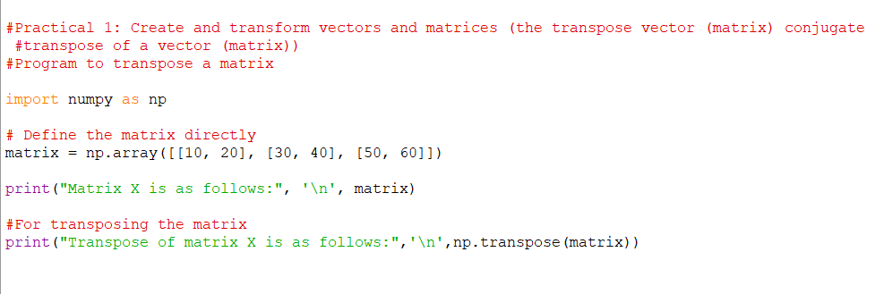

**Output:-**

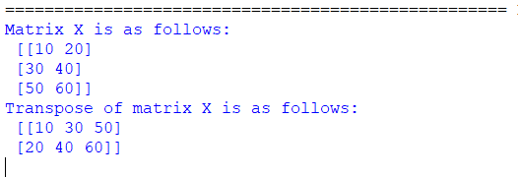

**# Practical 2**

**Generate the matrix into echelon form and find its rank.**

**Code:-**

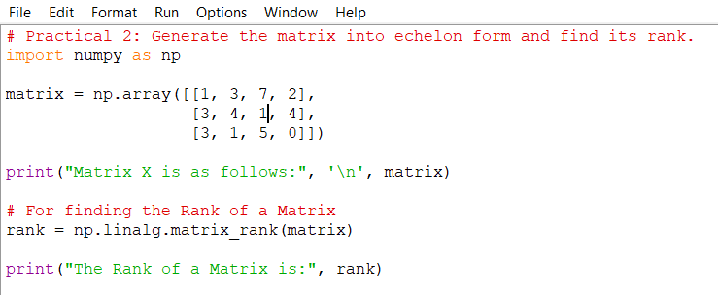

**Output:-**

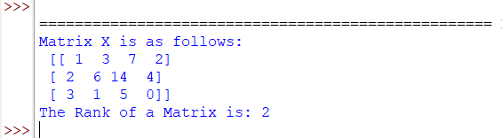

**# Practical 3**

**Find cofactors, determinant, adjoint and inverse of a matrix.**

**Code:-**

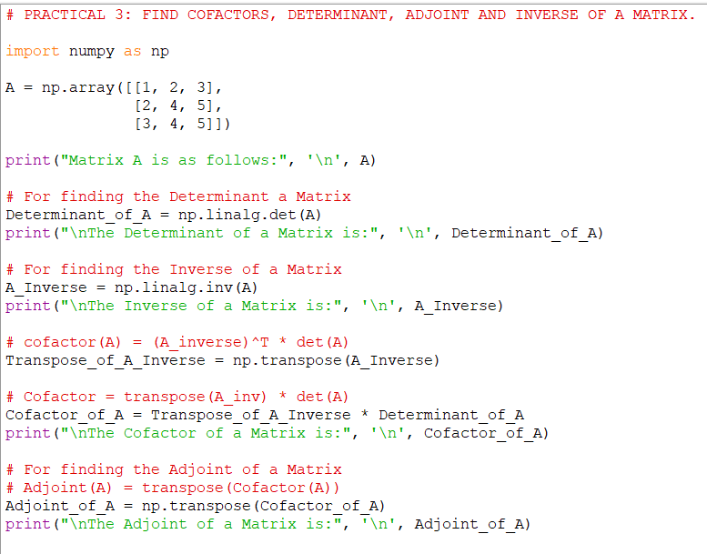**Output:-**

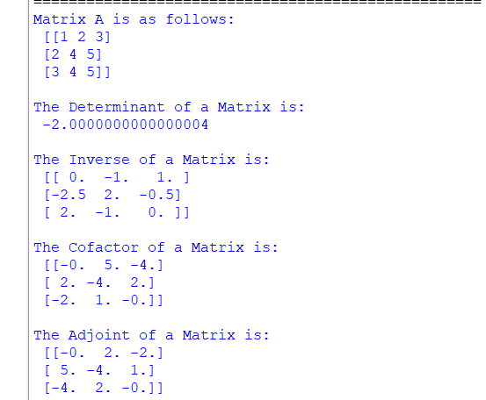

**# Practical 4**

**Solve a system of Homogeneous and non-homogeneous equations using**

1. **Gauss elimination method.**

**Code:-**

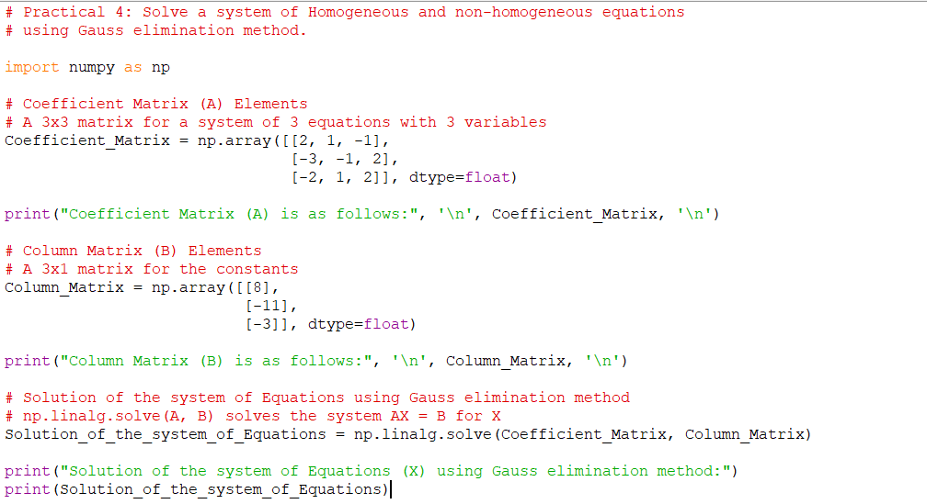

**Output:-**

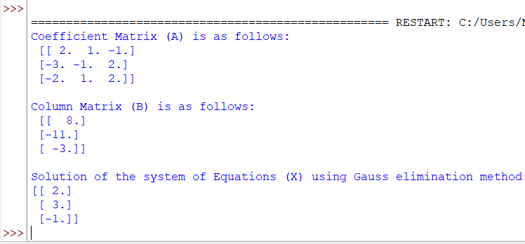

**# Practical 5**

**Solve a system of Homogeneous equations using the Gauss Jordan method.**

**Code:**

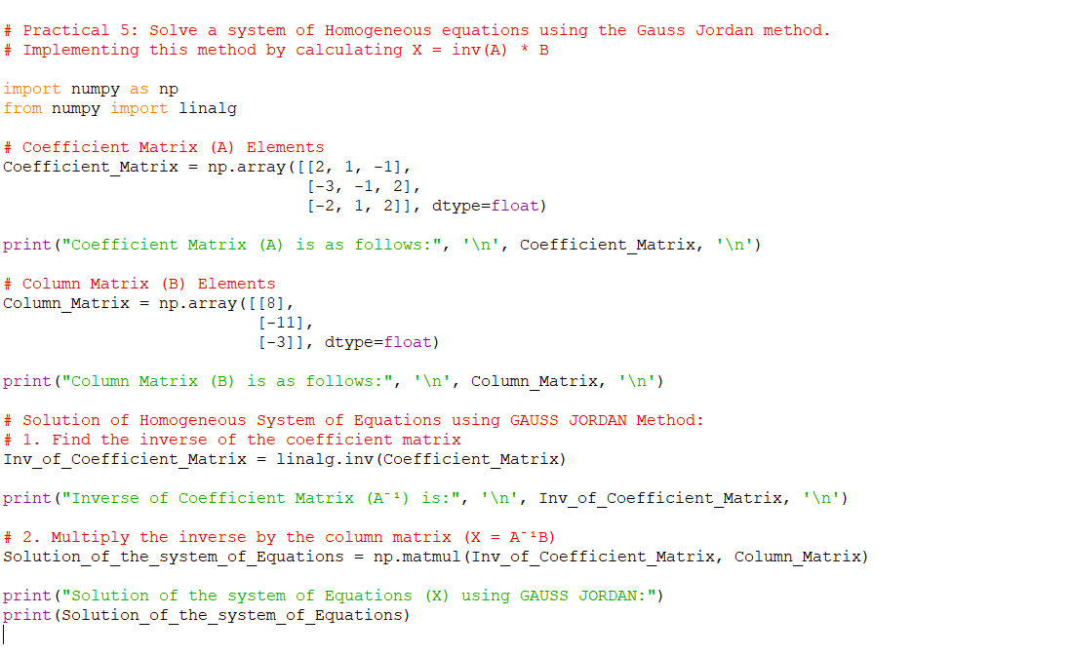

**Output:-**

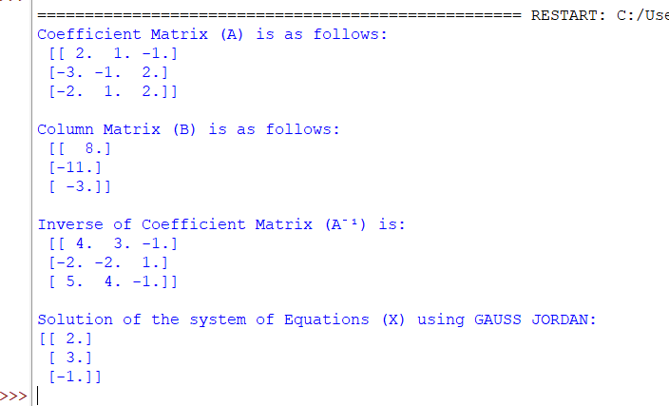

**# Practical 6**

**Generate basis of column space, null space, row space and left null space of a matrix space.**

**Code:-**

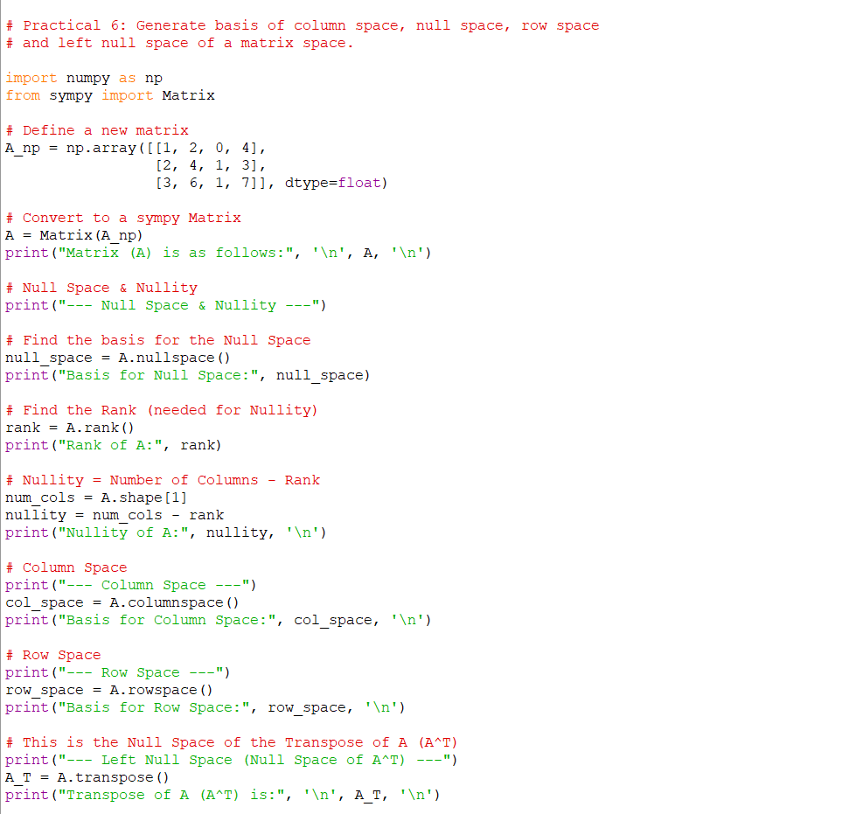

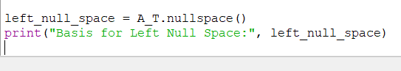

**Output:-**

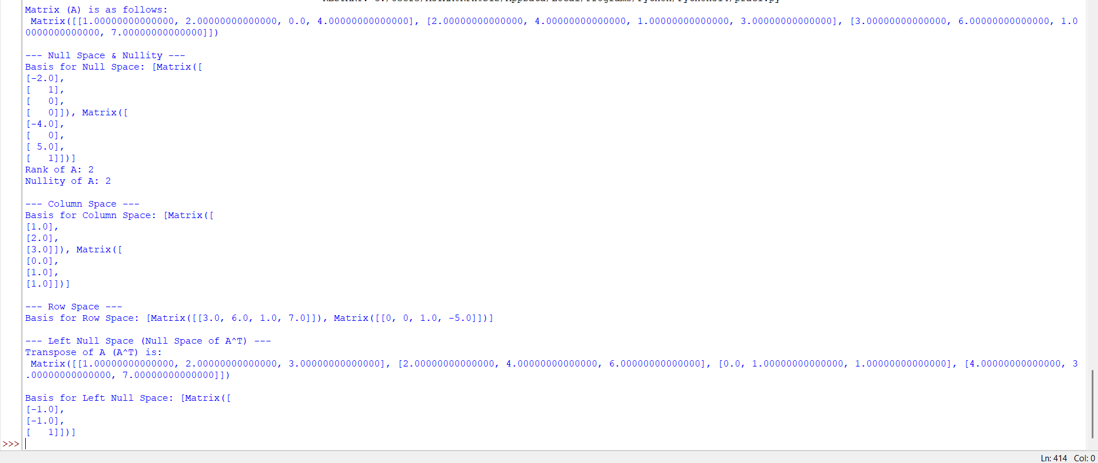

**# Practical 7**

**Check the linear dependence of vectors. Generate a linear combination of given vectors of Rn/ matrices of the same size and find the transition matrix of given matrix space.**

**Code:**

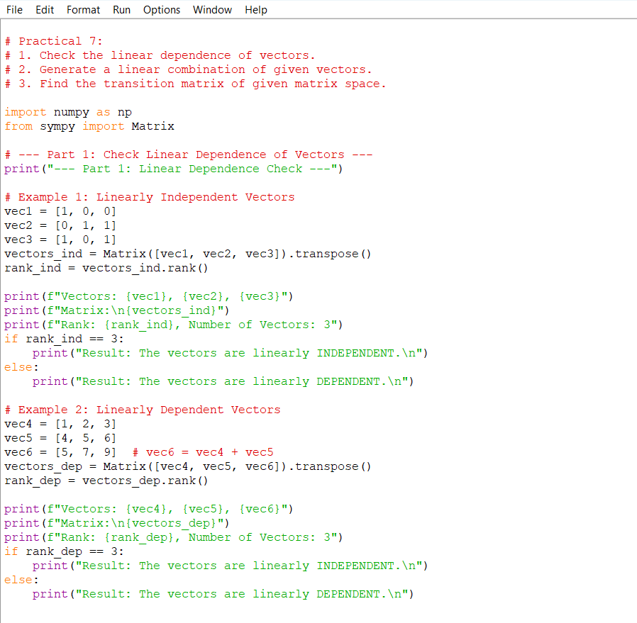

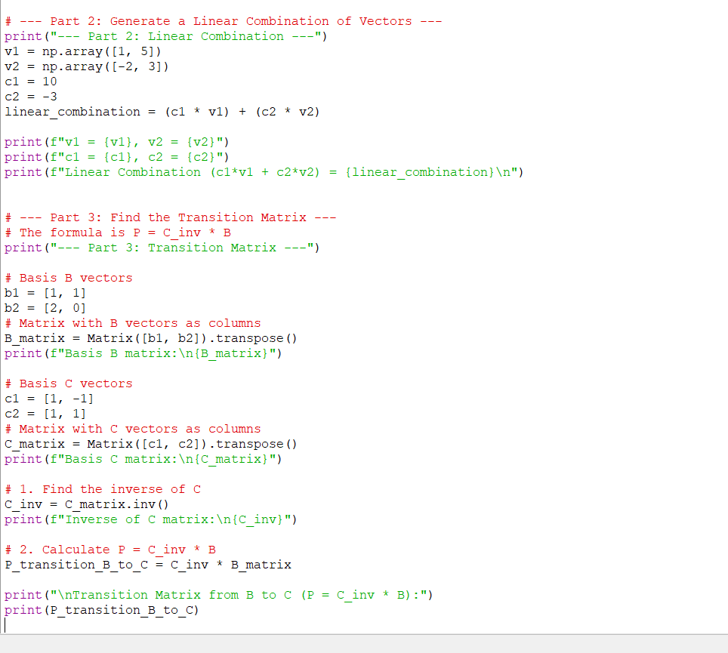

**Output:-**

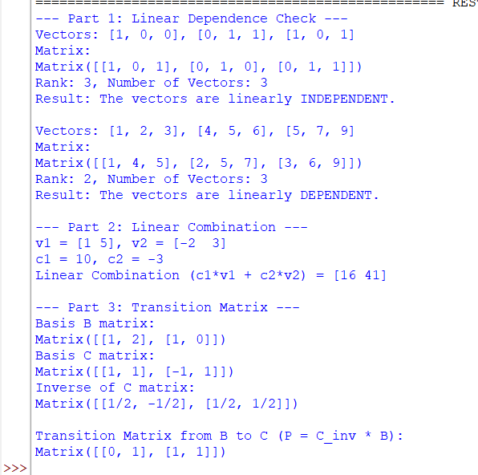

**# Practical 8**

**Find the orthonormal basis of a given vector space using the**

**Gram-Schmidt orthogonalization process.**

**Code:-**

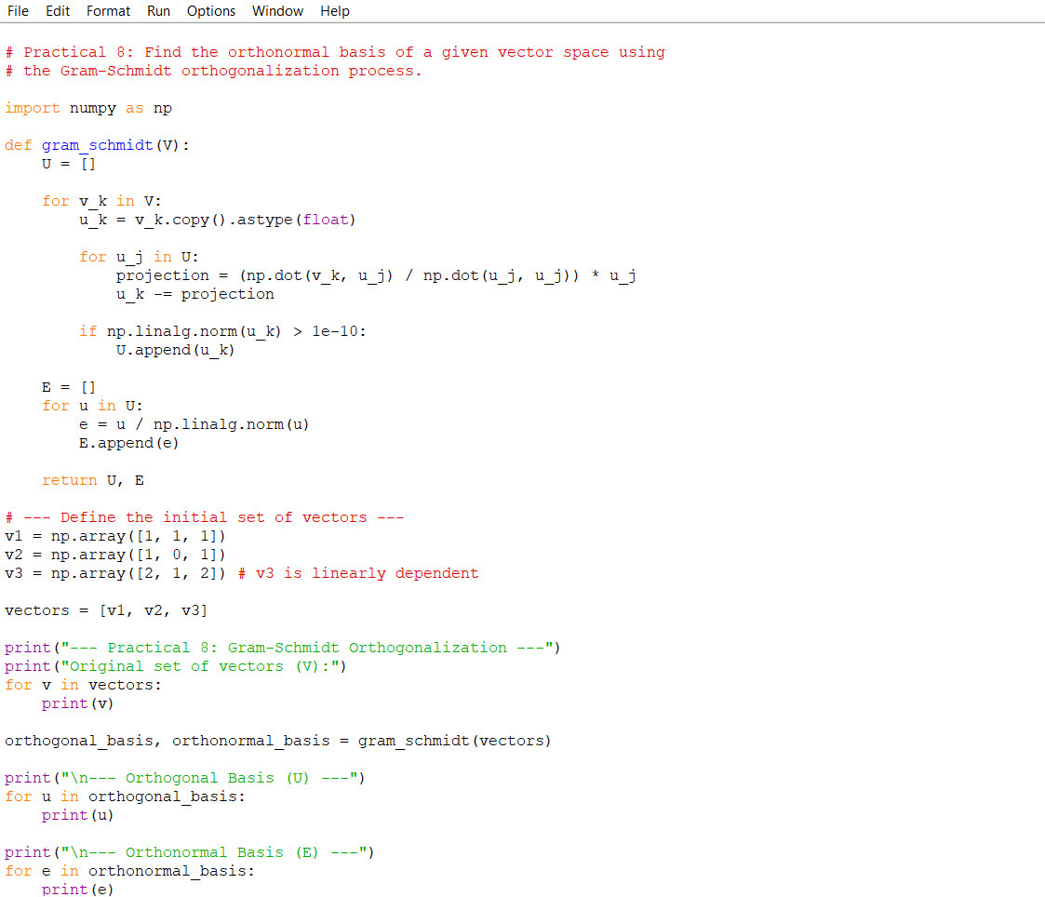

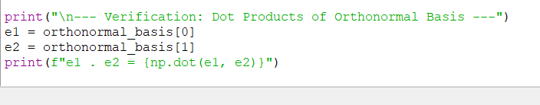

**Output:-**

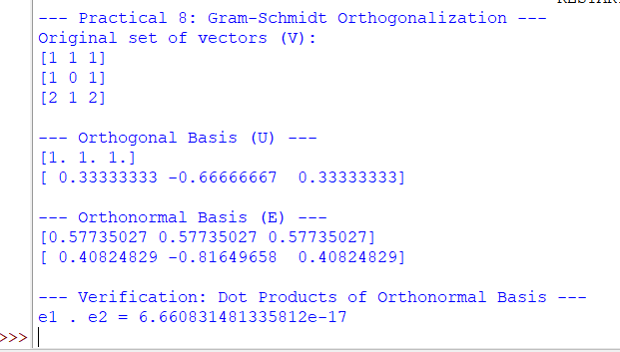

**# Practical 9**

**Check the diagonalizable property of matrices and find the corresponding eigenvalue and verify the Cayley- Hamilton theorem**

**Code:-**

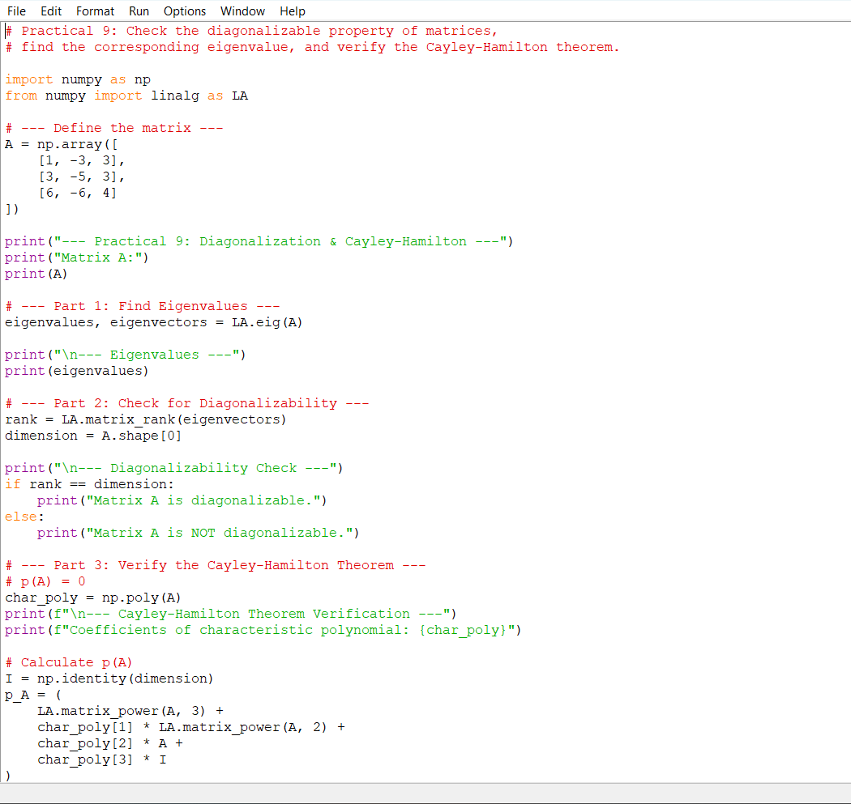

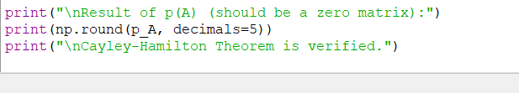

**Output:-**

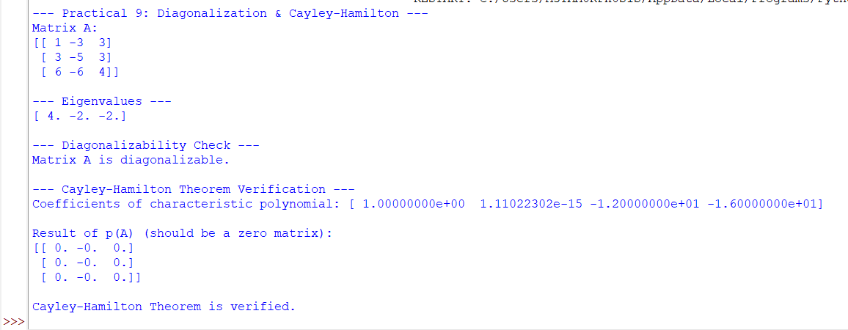

**# Practical 10**

**Application of Linear algebra: Coding and decoding of messages using nonsingular matrices. eg code “Linear Algebra is fun” and then decode it.**

**Code:-**

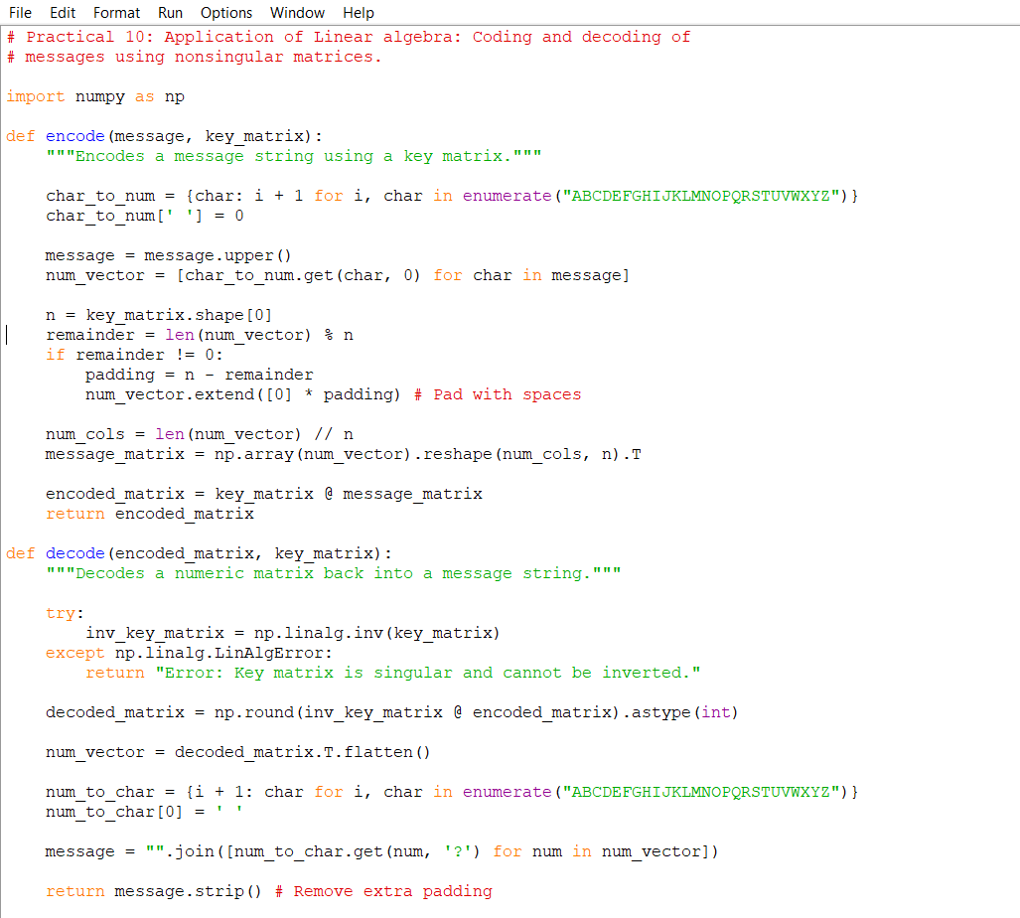

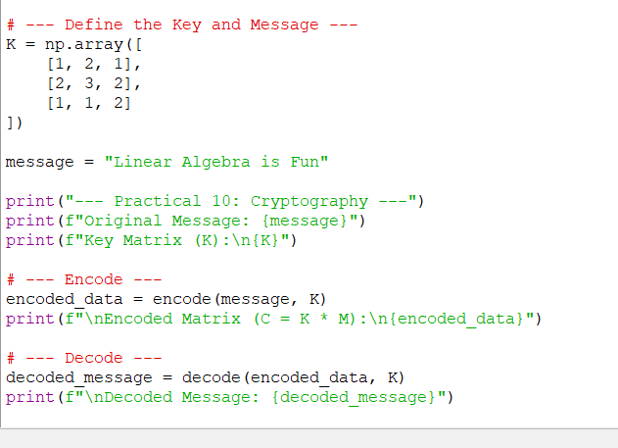

**Output:-**

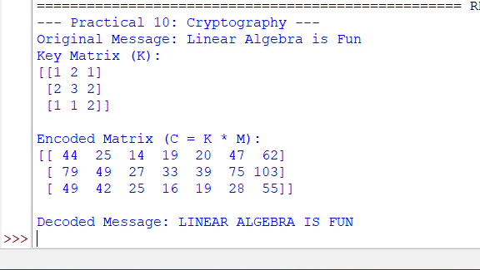

**# Practical 11**

**Compute Gradient of a scalar field.**

**Code:-**

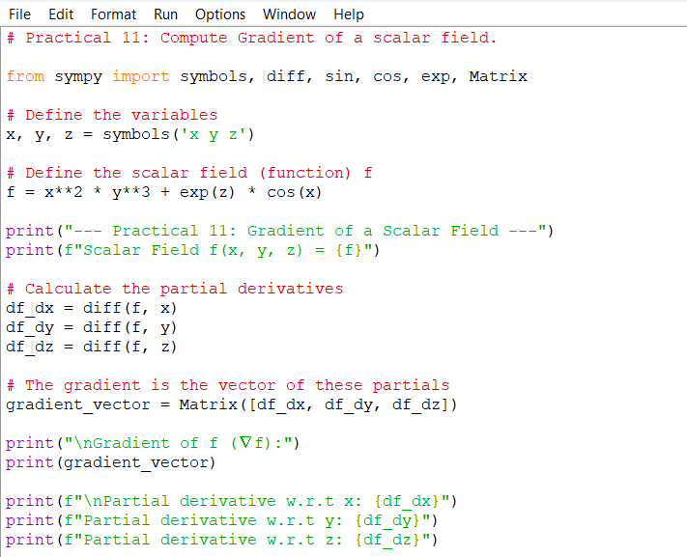

**Output:-**

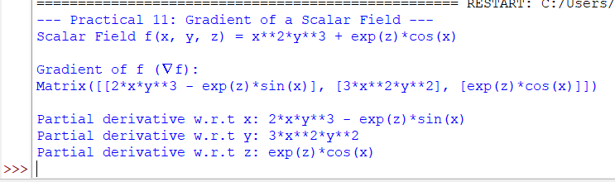

**# Practical 12**

**Compute Divergence of a vector field.**

**Code:-**

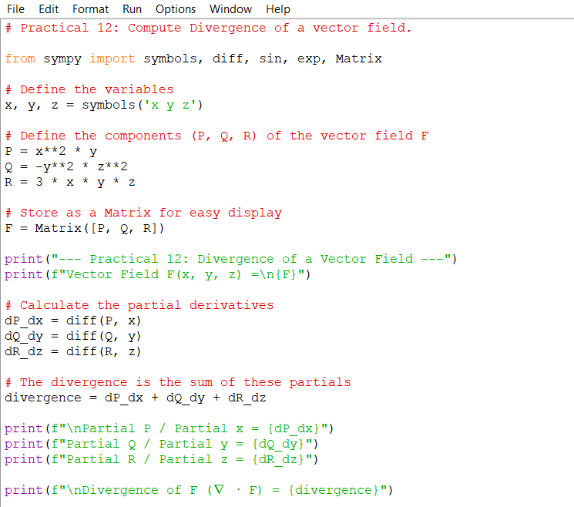

**Output:-**

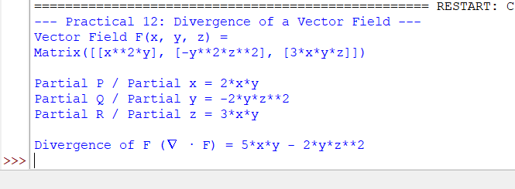

**# Practical 13**

**Compute Curl of a vector field.**

**Code:-**

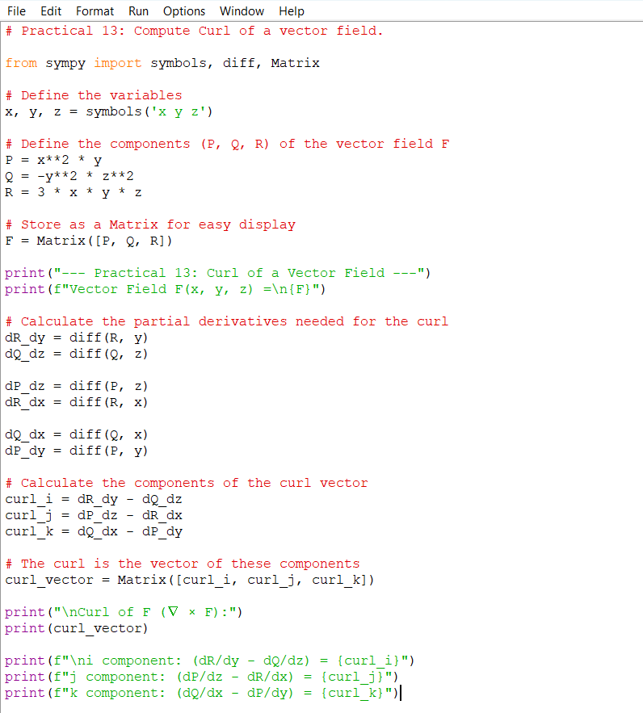

**Output:-**

